UniBridge Project Report

Project Structure & Maven Setup
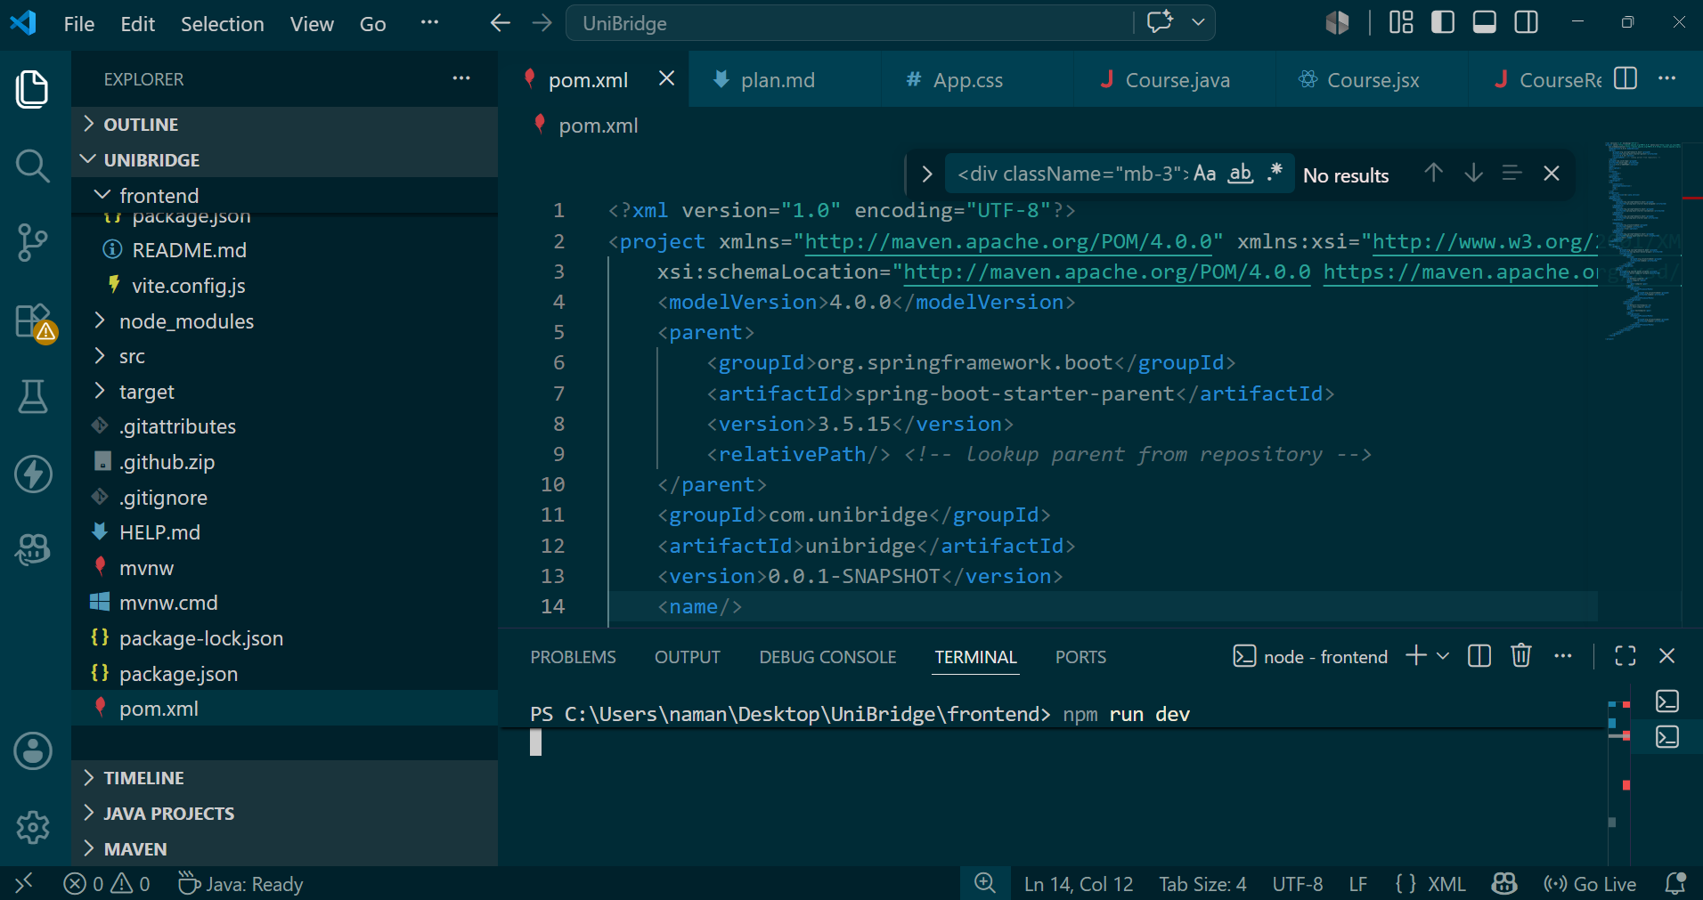
The Spring Boot backend and React frontend are organized in a structured project layout. Maven is used to manage dependencies and build the backend application.
The project configuration ensures smooth integration between frontend and backend modules.

Student Controller
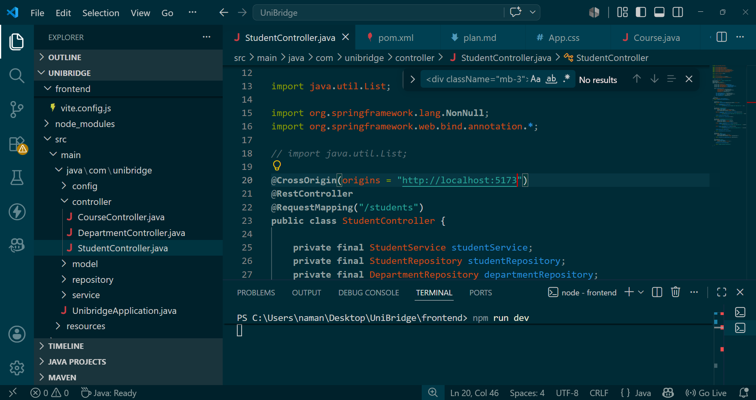
StudentController.java handles REST API requests related to student management. CRUD operations are exposed through Spring Boot endpoints.
This controller connects the frontend forms with MongoDB data through service and repository layers.

Course Controller
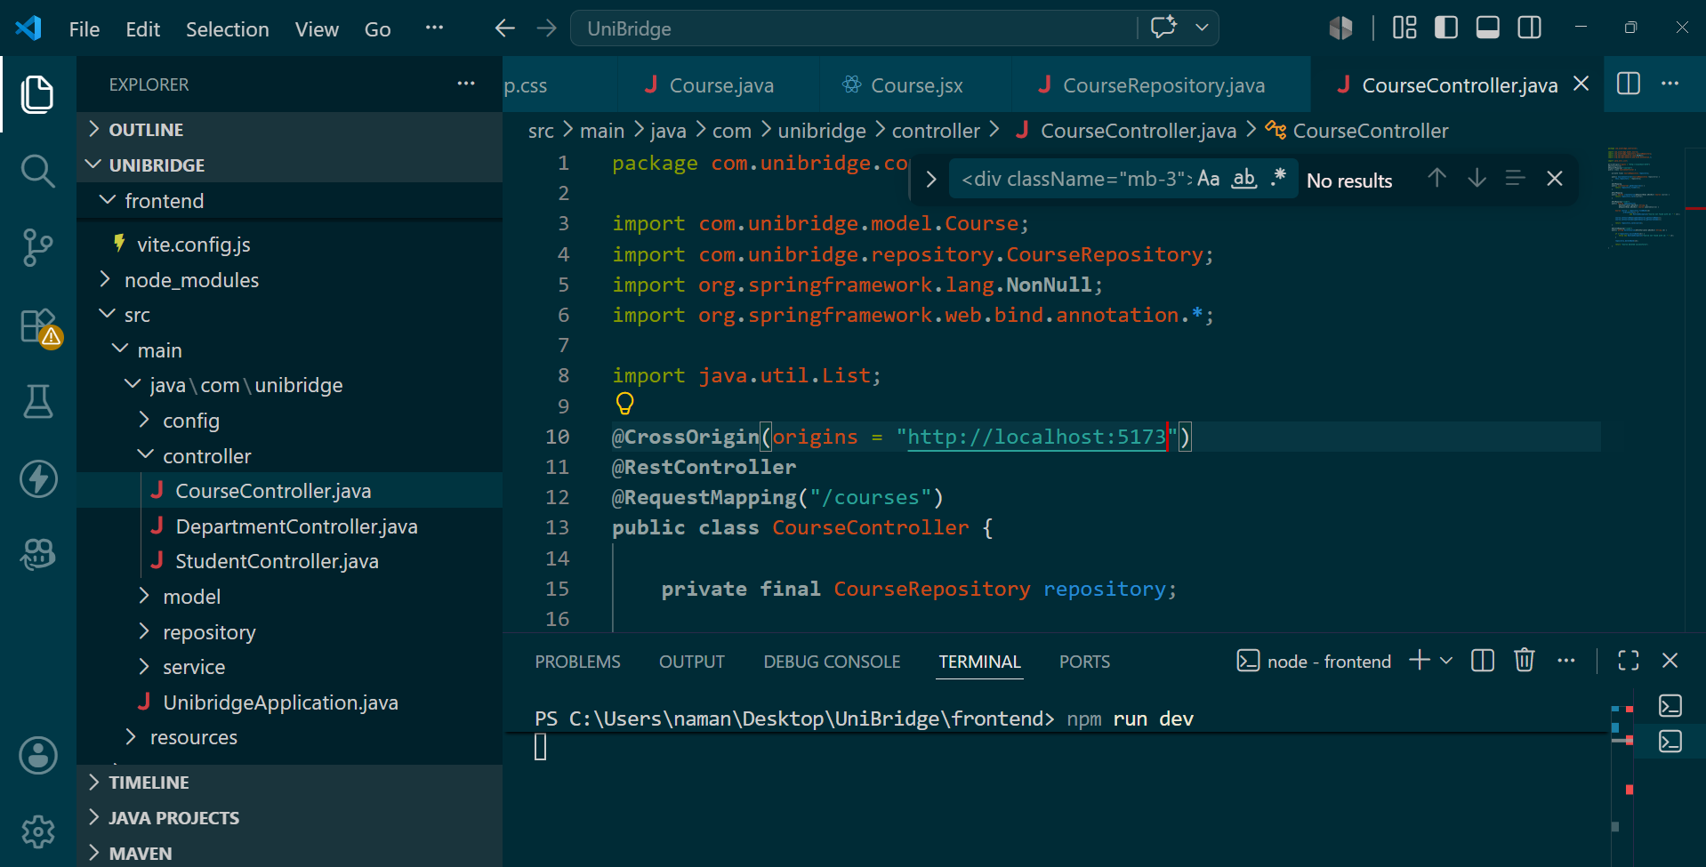
CourseController.java manages course-related API operations. It provides endpoints to create, update, delete, and fetch course records.
The controller helps maintain course information used throughout the UniBridge system.

Department Controller
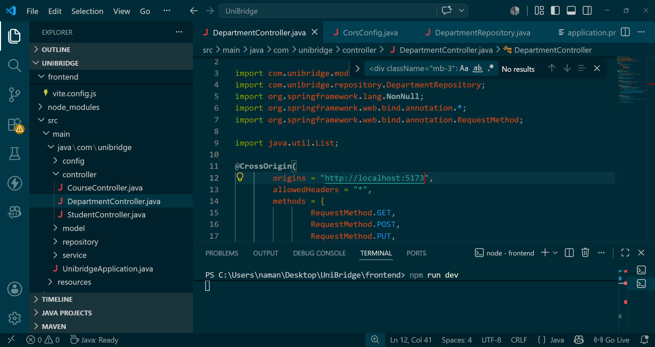
DepartmentController.java handles department management APIs. CORS configuration allows communication from the React frontend.
It ensures department data is available for student and enrollment modules.

Course Model
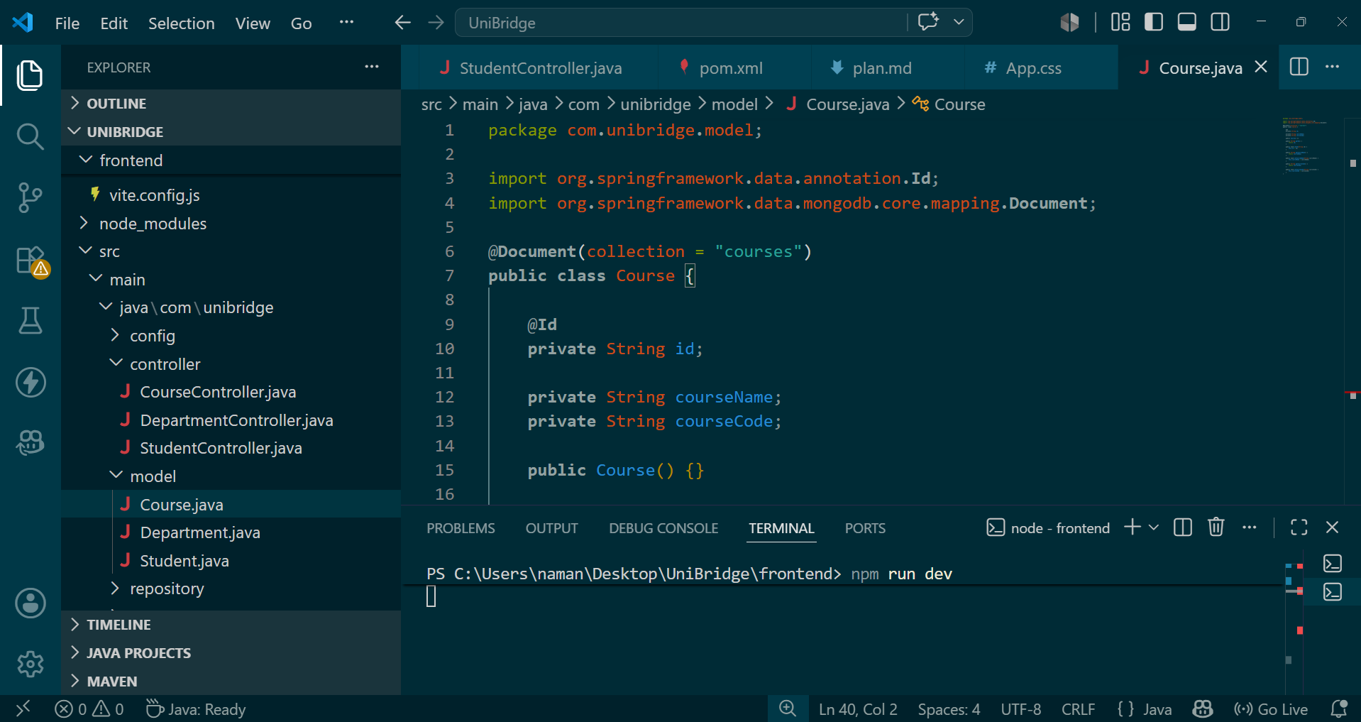
The Course model represents the courses collection in MongoDB. It defines fields such as course name and course code.
This model is used for storing and retrieving course information from the database.

Department Model
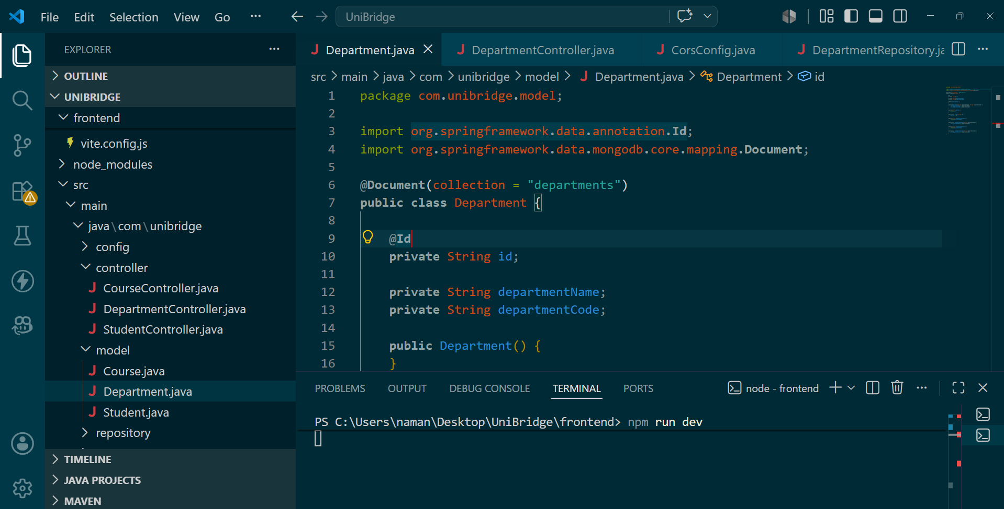
The Department model maps department records into MongoDB documents. It contains department identifiers and department details.
This structure helps maintain organized academic department data.

Student Model
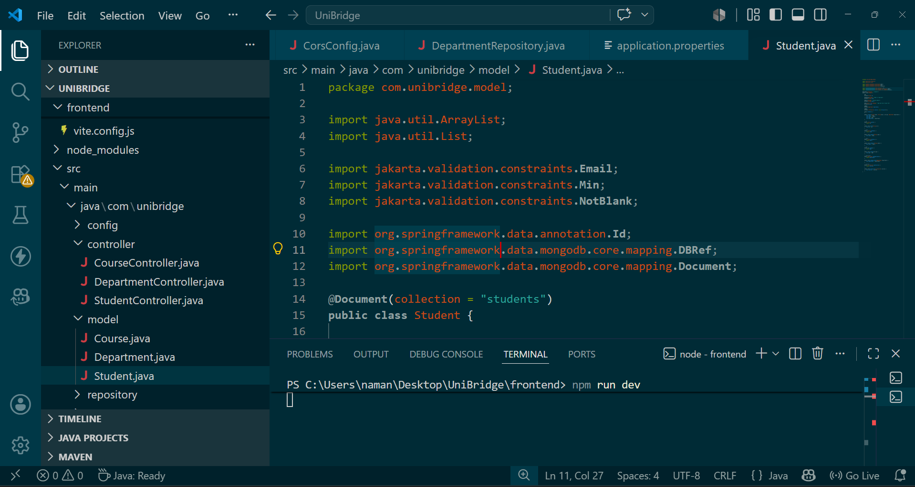
The Student model stores student information and references related entities. Validation annotations help ensure data integrity.
MongoDB annotations are used for document mapping and persistence.

Student Frontend Page
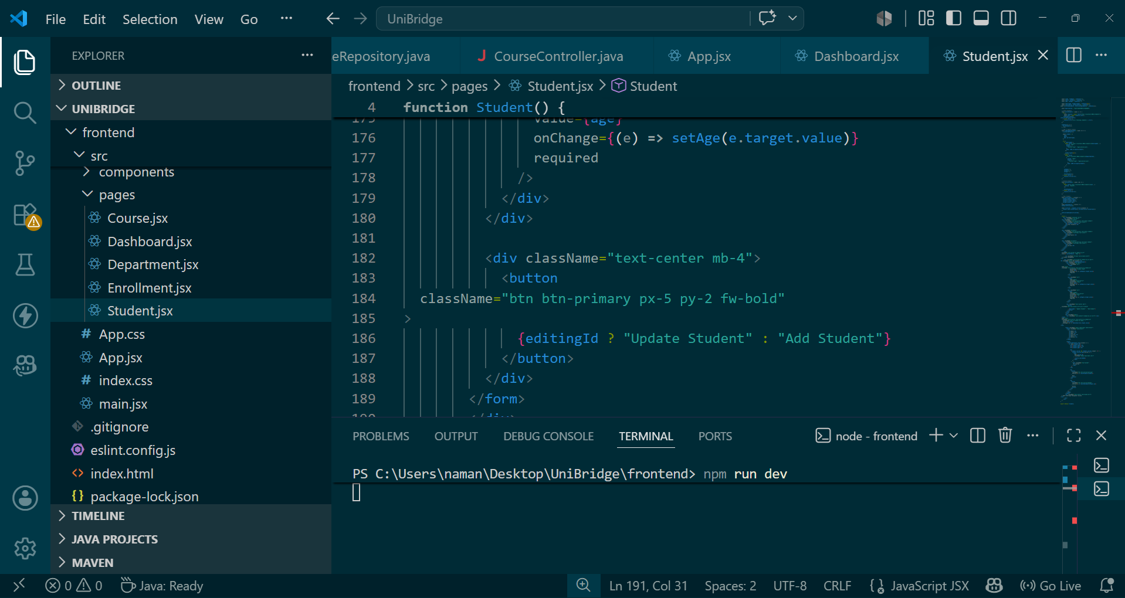
Student.jsx provides the user interface for student management. React state management is used for handling form data and API calls.
The page allows users to add, edit, search, and delete student records.

React Routing
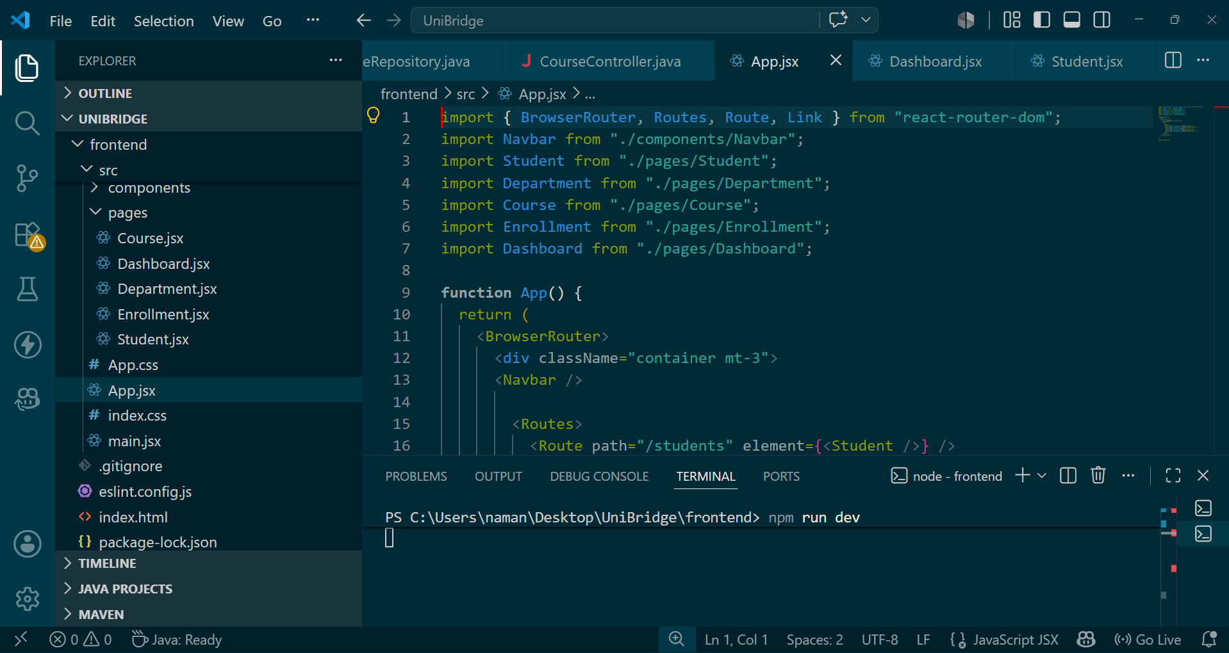
App.jsx configures navigation using React Router. Different pages such as Students, Courses, Departments, and Enrollments are connected through routes.
This enables seamless navigation across the application.

Application Output
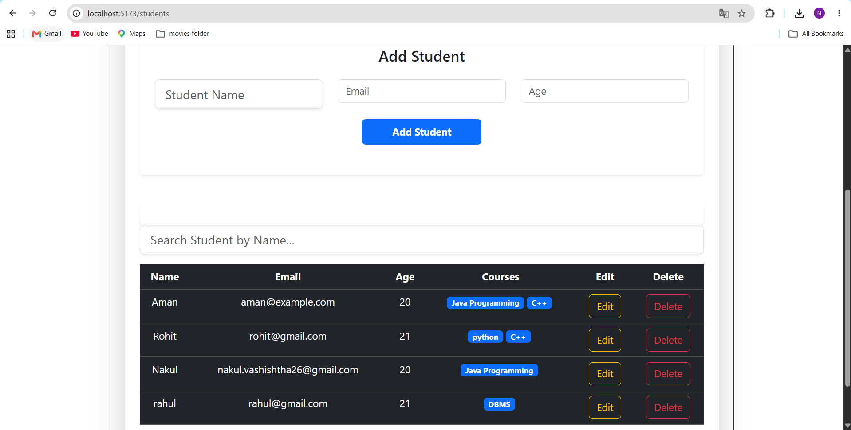
The final output displays student records in a responsive table. Users can search, edit, and delete records through the interface.
The successful output confirms proper integration of React, Spring Boot, and MongoDB.

